

Final Investigation Report
On

Offline Patch Management for Virtual Machines

A Report from

Sahana Sampige Prabhakar, Expert
(hp Bangalore ESSN R&E)

Bharath SN, Intern
( hp Bangalore ESSN R&E )

Fazil Khan, Saud
( hp Bangalore ESSN R&E )
Table of Contents

Introduction……………………………………………………………3
- Need for Offline Patching……………………………………………..4
- Competitive Study……………………………………………………4
- VMware’s Solution………………………………………………....7
- Microsoft’s DISM APIs………………………………………………8
- Our ideas for offline and online patching…………………………….8
- Few open questions………………………………………………….18
- Future Work…………………………………………………………18
- Improvements……………………………………………………….19
- Offline Patching of OS using Insight Control server migration…..19

- Introduction

Problem statement :-

Enterprise Datacenters have a number of servers put in cold storage and bring up on a need basis.

When these servers (Physical or Virtual) have to be brought up and on the network, they are usually out of date with respect to Operating System updates and patches. Hence they get flagged as non-compliant machines on the network. Existing Patch management systems work with systems that are online. It has been difficult to bring OS Images online to patch them. These servers are also vulnerable during that window when they first go online unpatched. Also it becomes an effort for administrator to remember to keep them patched with the latest patches soon after they are brought up to ensure IT compliance.

Solution Required :-

The requirement here is to investigate and come up with generic way to automatically address this by offline Virtual server OS patching and keep them up to date without bringing the server online. This ensures that offline servers are in a constant state of readiness to be deployed.

Offline patching definition :-

Patching is a critical security service that keeps computer systems up to date and defends against security threats. Existing patching systems all require running systems. Consider a server blade having multiple OS images. Hypervisor boots the OS images. Consider a scenario where 2 or more OS images offline and need to be updates. The actual procedure is to boot the OS images, which is now online, update it then save all the changes and allow the OSes to go offline. But in most of the cases booting the OSes require considerable amount of time which cant be tolerated and degrades the performance of servers.
The direct solution to the above problem is to allow all the OS images to be offline, means not to boot, patch them when the updates are available. Next time when the patched OS boots it must be patched and updated successfully as if it was patched online.

- Need for Offline patching

Patching is a critical security service that keeps computer systems up to date and defends against security threats. Existing patching systems all require running systems. With the increasing adoption of virtualization and cloud computing services, there is a growing number of dormant virtual machine (VM) images. Such VM images cannot benefit from existing patching systems, and thus are often left vulnerable to emerging security threats. It is possible to bring VM images online, apply patches, and capture the VMs back to dormant images. However, such approaches suffer from unpredictability, performance challenges, and high operational costs, particularly in large-scale compute clouds where there could be thousands of dormant VM images.

Patching is a basic and effective mechanism for computer systems to defend against most, although not all, security threats, such as viruses, rootkits, and worms. Failing to promptly patch physical machines can subject the systems to huge risks, such as loss of confidential data, compromise of system integrity, and failure to provide regular system services. Unfortunately, applying security patches is a notoriously tedious task, due to the large number of patches and the high rate at which they are released — it is estimated that, in an average week, vendors and security organizations release about 150 vulnerabilities and associated patching information. As a result, most software runs with outdated patches.

In general, patching approaches that require VMs to be online are a poor fit for VM images in compute clouds. Note that it takes on the order of minutes just to power up and shut down a VM image. With the large number of dormant VM images that are infrequently used, these approaches add significant extra costs either for customers or for cloud service providers. In addition to these costs, bringing a VM image online necessarily runs code that has nothing to do with patching, which makes patching less predictable. It speeds up the patching process by more than 4 times compared to the online approach.

- Competitive Study

  - Microsoft’s approach:- Microsoft Offline Virtual Machine Servicing Tool brings the VM image online, applies the patches, and captures the VM back to a dormant/inactive image. Assuming that not all VM images are needed immediately by their users, ( they call it as a lazy patching approach ) which injects the patch installer and patch data into the VM image in such a way that the patch process is triggered at the next booting time. However, the tradeoff is that users will now see delays in image startup, which can be significant for images that have accumulated a long list of yet-to-be-applied patches.
Offline patching solutions: - Microsoft System Center 2012 - Virtual Machine Manager (VMM) is a management solution for the virtualized data center, enabling organizations to configure and manage virtualization host, networking, and storage resources to create and deploy virtual machines and services to private clouds.

VHD (Virtual Hard Disk) is a file format which represents a virtual hard disk drive (HDD). It may contain what is found on a physical HDD, such as disk partitions and a file system, which in turn can contain files and folders. It is typically used as the hard disk of a virtual machine. VHD files provide some offline operations. Those are as follows,

- Hyper-V features offline VHD manipulation, providing administrators with the ability to securely access files within a VHD without having to instantiate a virtual machine. This provides administrators with granular access to VHDs and the ability to perform some management tasks offline. The Windows Disk Management MMC plugin can directly attach a .vhd as a drive letter in Windows 7, Windows Server 2008 (64 bits) and Windows Server 2008 R2.
- Moving files between a VHD and the host file system
- Backup and recovery
- Antivirus and security
- Image management and patching
- Disk conversion (physical to virtual, and so on)
- Life-cycle management and provisioning

Offline modifications:
- modifying a VHD file without booting the underlying OS.
- Updating a windows image contained in a mounted WIM file.
- A windows image has been applied to a VHD but the virtual machine is not currently running.

In short Microsoft uses the .vhd files to carry out the offline patching by mounting the image (also .vhd files). Mounting will not consume much time and also it will not degrade the performance. Finally we can get the updated OS as soon as we boot the patched .vhd image file.

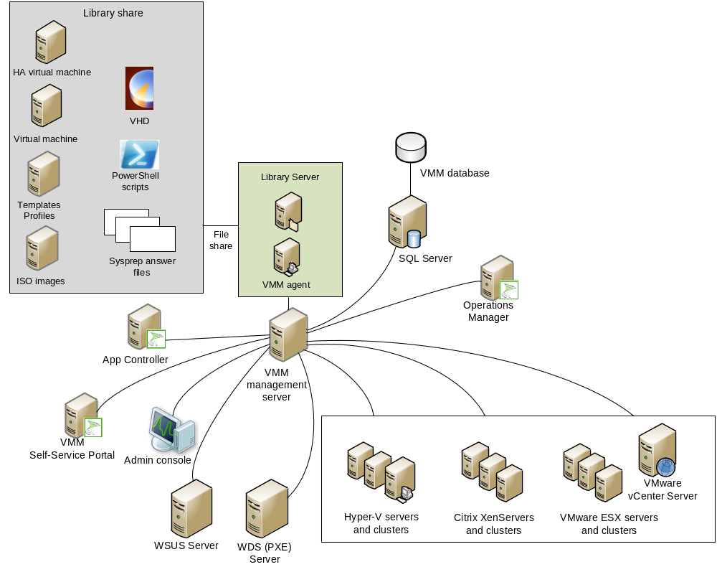
Reference image from Microsoft.

  - VMware’s approach:- vSphere client

Simplify VMware vSphere management by automating patches and updates. vSphere Update Manager makes it easy to manage tracking and patching of vSphere hosts
- Keep machines up to date and in compliance
- Reduce risks of patching
- Eliminate vSphere downtime related to host patching
Keep Machines Up-to-date and in Compliance:
Automate patch management and eliminate manual tracking and patching of vSphere hosts and virtual machines. vSphere Update Manager compares the state of vSphere hosts with baselines, then updates and patches to enforce compliance to mandated patch standards.
- Gain visibility into patch status across the virtual infrastructure with a patch compliance dashboard
- Stage and schedule patching for remote sites.
- Deploy offline bundles of patches downloaded directly from vendor websites

Reduce the Risks of Patching
- Store snapshots for a user-defined period so administrators can roll back the virtual machine if necessary
- Securely patch offline virtual machines without exposing them to the network, reducing the risk of non-compliant virtual machines
- Make sure the most current version of a patch is applied with automatic notification services
VMware uses its own file format , “VMDK” , to achieve offline patching. vSphere client is used to mount the .vmdk files to patch it in offline mode. vCenter update manager is used for patching purpose. The VMware ESX is then used to boot the .vmdk files.

- VMWare’s Solution
VMWare has a product called “vCenter Protect” specifically for patching purpose. Like vSphere Client, vCenter Protect uses the vCenter server running on a remote machine. In vCenter Protect we have to manually add the VMs and set the IP addresses accordingly.
Features available:
- Asset inventory:- (for both virtual and physical assets) leverages our innovative agentless technology to thoroughly and dynamically discover and catalog all the assets that IT must manage.
- Patch Management
- Offline VM Patching
- Agentless and agent-based
- Snapshot
- Antivirus
- Power Management
- ITScripts
Patching mechanism: - It creates a batch file and pushes it out to the target machine, we should be able to find them in the following directory on the target VM : C:\Windows\ProPatches\Install You may also note that successfully executed batch files are renamed to .HIS files as the last step in the process. While booting windows configures and gets updated itself. In the above mentioned path we can also find the downloaded patches. vCenter protect doesn’t support the patching of Linux machines.

- Microsoft’s Solution

The Deployment Image Servicing and Management (DISM) tool replaces the pkgmgr, PEImg, and IntlConfg tools that are being retired in Windows 7. DISM provides a single centralized tool for performing all of the functions of these three tools in a more efficient and standardized way, eliminating the source of many of the frustrations experienced by current users of these tools.
DISM includes a shim for Windows Vista SP1 and later, as well as for Windows Server 2008 RTM and later, that redirects pkgmgr calls from legacy applications running on Windows 7 to DISM. If the application is running on one of the supported operating systems, the shim routes the call to pkgmgr. No shims exist for legacy applications that call PEImg or IntlConfg.

- Our ideas for offline and online patching

  - Patching of windows machines

Online patching Mechanism: Online patching is a straight process where we can use “DISM” directly on the target machine. Simple DISM command will suffice the required task.

Command: “Dism /online /AddPackage /PackagePath:C:\<path to the patches> /NoRestart /quiet”

Refer :- http://technet.microsoft.com/en-us/library/dd744382(v=ws.10).aspx

Offline patching Mechanism: - Initially before performing the patching process Boot the Win-PE in order to perform the following operations.
- Mount the disks of the VM from Win-PE.
Or
If we wish not to use Win-PE, we can mount the VMs hard disk i.e *.vhd files (only possible for Windows HyperV VMs) using DISKPART command.
- Then use DISM commands to patch.
- Finally commit and unmounts.

Simple script for performing the above task on .vhd

File name “offline.bat”

echo off
diskpart /s attach-script.txt
pause
dism /Image:D:\ /add-package /packagepath:C:\updates\
pause
diskpart /s detach-script.txt
pause

file name “attach-script.txt”

select vdisk file="C:\Virtual Machines\Windows VM2\Windows VM2.vhd"
attach vdisk

file name “detach-script.txt

select vdisk file="C:\Virtual Machines\Windows VM2\Windows VM2.vhd"
detach vdisk

Patching of linux machines

Patching of linus is not a straight forward process. Online patching is simple, go to “synaptic package manager” for checking updates and patch it. It is purely under the control of operating system.

The real burden of patching linux comes into picture in offline mode. For that purpose we have used the Runlevel feature in linux machines.

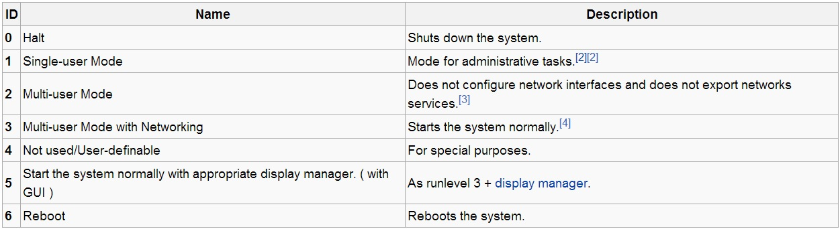

In the single-user mode runlevel the network adapter will be disabled and in that runlevel just add a script for patching and at the end of the script put the command “reboot” the system will automatically restart. It is recommended to make use of runlevel 4 as it is a user defined. The below script is particularly coded for Ubuntu VM, we can also modify the script according to our needs.

Following is our approach for offline patching :
- Boot the Linux-PE on the VM.
- Mount the VM’s disks using Linux –PE.
- Copy the patch files to be updated in the VM’s disk.
- Copy the patch script to a location in VM’s disk as shown below.
- Using script running on Linux-PE configure the VM to boot into desired runlevel(preferred 4 in RHEL and SLES and 1 in Ubuntu).
- Using the same script, add a bootup script - which will install the patch files on VM on next bootup.
- And using the same script, issue a command using bootup script to reboot into the original runlevel of the VM.

Simple script for patching “basically a boot script on runlevel 1”

The script named “S72hello”

#!/bin/sh

echo "!@$!%!!@#%!@$#%%@#$%@$%@$^%$@#^!@$%@!$%"

folder=/offline_patch/updates
RUN_LEVEL_PATH=/etc/init/rc-sysinit.conf
SAVED_RUNLEVEL=/offline_patch/run_save.txt
LOG=/offline_patch/update.log
ERROR=/offline_patch/update_error.log

if [ "$(sudo ls -A $folder/*.deb)" ]
then
echo "updates found !! "
echo $(echo "updates found in the location $PATH_TO_MOUNTED_UPDATE_FOLDER at : ") $(date) > $LOG
dpkg -i $folder/*.deb

else
echo "no updates found"
echo "no updates found at $folder" | tee -a $LOG >> $ERROR
exit 2
fi
<<comment
if [ $? -ne 0 ]
then
echo "error while installing patches to the system"
sleep 4
exit 2
else
echo "updated successfully ....!!!!!!"
sleep 3
fi
comment

#now modify the runlevel

if [ -f $RUN_LEVEL_PATH ]
then
echo "$RUN_LEVEL_PATH file exists." > $LOG
if [ -f $SAVED_RUNLEVEL ]
then
echo "found saved runlevel file" | tee -a $LOG
read line < $SAVED_RUNLEVEL
if [ -z $line ]
then
echo "couldnt find the saved runlevel/file is empty"
echo "couldnt find the saved runlevel in the $SAVED_RUNLEVEL / file is empty" | tee -a $LOG >> $ERROR
else
sed -i "s/env DEFAULT_RUNLEVEL=./$line/g" $RUN_LEVEL_PATH
if [ $? -ne 0 ]
then
echo "failed to modify"
echo "failed to modify the file $RUN_LEVEL_PATH, may be you dont have enough permission to perform this operation" | tee -a $LOG >> $ERROR
exit 3
else
echo "successfully modified"
echo "successfully modified the file $RUN_LEVEL_PATH" |tee -a $LOG
fi
fi
else
echo "could not find the saved runlevel file" | tee -a $LOG >> $ERROR
exit 2
fi
else
echo "file $RUN_LEVEL_PATH doesnt exist"
#may be you are using different flavour of linux, in each and every flavour path ll be different
echo "you might be using the different flavour of linux"
exit 2
fi

sleep 3
reboot

The script that runs on a linuxPE or SMP BootCD( as we did a POC for SMP)
Filename: offline.sh

#!/bin/bash

#unmount function
unmount()
{
#unmounting now .............
echo "unmounting the VM...."
sudo mv /logs $PATCH_ROOT
sudo umount $Mount_Path
if [ $? -ne 0 ]
then
echo "something went wrong while unmounting. check error file on the Desktop"
exit 2
else
echo "unmounted successfully from the location $Mount_Path "
echo $(echo "unmounted successfully from the location $Mount_Path at : ") $(date)
fi
sleep 10
}

#function to get the bootable device for mounting

get_path()
{
sudo fdisk -l | grep "*" | grep "/dev/" > temp
while read -n1 char
do
if [ "$char" != "*" ];
then
dev_path=$dev_path$char
else
break;
fi
done < temp
}

sudo -S mkdir /logs
sudo chmod 777 /logs

#required Paths
Mount_Path=/tmp/mount-point
PATCH_ROOT=$Mount_Path/offline_patch
F=/logs/new.log
LOG=/logs/logs.log
ERROR=/logs/error.log
RC_PATH=$Mount_Path/etc/rc1.d/
RUN_LEVEL_PATH=$Mount_Path/etc/init/rc-sysinit.conf
PATH_TO_MOUNTED_UPDATE_FOLDER=$Mount_Path/offline_patch/updates
dev_path=""

#mounting the virtual machine
#create a mount point to mount the filesystem
echo $(echo "mounting device at ... : ") $(date) | tee -a $F > $LOG
mkdir $Mount_Path

if [ $? -ne 0 ]
then
echo "error occured while creating a folder. Check log file for more info"
echo "seems u dont have enough permission to create a folder" | tee -a $LOG > $ERROR
exit 2
else
echo "mount-point created successfully in the location $Mount_Path"
echo $(echo "mount-point created successfully in the location $Mount_Path at : ") $(date) | tee -a $LOG >> $F
fi

sleep 5

#call function "get_path" to detect the path
get_path
#now mount the file/ VM
sudo -S mount $dev_path $Mount_Path

if [ $? -ne 0 ]
then
echo "something went wrong while mounting. check error file on the Desktop"
sudo mount /dev/sda1 $Mount_Path | tee -a $LOG >> $ERROR
exit 2
else
echo "mounted successfully in the location $Mount_Path "
echo $(echo "mounted successfully in the location $Mount_Path at : ") $(date) | tee -a $LOG >> $F
fi

sleep 5

<<comment
file type of the patch

echo "select the file type of the patch"
echo "1 .tar.gz package"
echo "2 .deb"

read file_type
comment

<<comment
case $file_type in
1 ) echo "enter the Path of the file"
if [ -f $tar_path ]
then
tar -zxvf $tar_path $Mount_Point/home/bharathsn/Desktop/
if [ $? -ne 0 ]
then
echo "Error while Extracting the patch file"
echo "Error while Extracting the patch file" | tee -a $LOG > $ERROR
exit 3
else
echo "Extracted successfully to the Desktop"
echo $(echo "Extracted successfully to the $Mount_Point/home/bharathsn/Desktop/ on: ") $(date) |tee -a $LOG >> $F
fi
#execution of the INSTALL script that comes with the package goes here

else
echo "file not found"
echo "make sure you have entered the correct path" | tee -a $LOG > $ERROR
exit 3
fi ;;

3 ) echo "enter the path of the folder where the patch file is present"
read tar1_path
echo "enter the filename of the patch with out extension"
read file_name
if [ -f $tar1_path/$file_name.rpm ]
then
sudo alien -k $tar1_path/$file_name.rpm
sudo chmod 777 $tar1_path/$file_name.deb
sudo cp $tar1_path/$file_name.deb $PATH_TO_MOUNTED_UPDATE_FOLDER

if [ $? -ne 0 ]
then
echo "Error while copying the patch file"
echo "Error while copying the patch file" | tee -a $LOG > $ERROR
exit 3
else
echo "copied successfully !!!"
echo $(echo "copied successfully on: ") $(date) |tee -a $LOG >> $F
fi
else
echo "file not found"
echo "make sure you have entered the correct path" | tee -a $LOG > $ERROR
exit 3
fi ;;
esac
comment

if [ "$(sudo ls -A $PATH_TO_MOUNTED_UPDATE_FOLDER/*.deb)" ]
then
echo "updates found !! "
echo $(echo "updates found in the location $PATH_TO_MOUNTED_UPDATE_FOLDER at : ") $(date) | tee -a $LOG >> $F
else
echo "no updates"
echo "no updates in $PATH_TO_MOUNTED_UPDATE_FOLDER" | tee -a $LOG >> $ERROR
unmount
exit 2

fi

sleep 5
#now search for the file named rc-sysinit.conf

if [ -f $RUN_LEVEL_PATH ]
then
echo "$RUN_LEVEL_PATH file exists." | tee -a $LOG >> $F
grep "env DEFAULT_RUNLEVEL=." $RUN_LEVEL_PATH > $PATCH_ROOT/run_save.txt
if [ $? -ne 0 ]
then
echo "could not find the run level pattern in $RUN_LEVEL_PATH"
echo "could not find the run level pattern in $RUN_LEVEL_PATH, may be you dont have enough permission to perform this operation" | tee -a $LOG > $ERROR
unmount
exit 3
else
echo "saved the default runlevel to the file run_save.txt"
echo $(echo "saved the default runlevel to the file run_save.txt") $(date) | tee -a $LOG >> $F
fi

sleep 10
sudo sed -i 's/env DEFAULT_RUNLEVEL=./env DEFAULT_RUNLEVEL=1/g' $RUN_LEVEL_PATH
if [ $? -ne 0 ]
then
echo "failed to modify the file $RUN_LEVEL_PATH"
echo "failed to modify the file $RUN_LEVEL_PATH, may be you dont have enough permission to perform this operation" | tee -a $LOG > $ERROR
unmount
exit 3
else
echo "successfully modified"
echo $(echo "successfully modified the file $RUN_LEVEL_PATH at :") $(date) | tee -a $LOG >> $F
fi
sleep 5
else
echo "file $RUN_LEVEL_PATH doesnt exist"
#may be you are using different flavour of linux, in each and every flavour path ll be different
echo "you might be using the different flavour of linux" | tee -a $LOG > $ERROR
unmount
exit 2
fi

sleep 5

#updation process completed
echo "Updation process completed"
echo $(echo "updation process completed on:") $(date) | tee -a $LOG >> $F
unmount
exit 0

- Few open questions:

- How to pass the offline.sh patch script to pre-boot environment programmatically?

Ans: There are 2 ways,

- We can pass it as the boot up script of the Pre-boot environment.
Or
- We can use the Automation Engine program, which will pick the files from the CMS. Automation Engine is a program which picks the files from remote computer using curl and allows users to execute the commands using xml file. Automation Engine is the HP proprietary software and this comes bundled with HP’s Pre-boot environment image.

- How to identify if the OS is already updated in linux when offline?

Ans: We can mount the offline disk and then check the following files in linux:

- For RHEL: run the command: cat <mount path location>/etc/rhel-release output: Red Hat Enterprise Linux 6.3 (Santiago) will be obtained if the RHEL 6.3 OS is installed.
- For SLES: run the command: cat <mount path location>/etc/sles-release output: Suse Enterprise Linux 10 SP4, will be obtained if the Sles 10 SP 4 OS is installed.

- Future Work

- As the above script involves some sort of manual work, we can extend idea or process by pushing scripts into the VMs – Like automating the end to end tasks (like bootup OS into PEs or mounting the files etc.) programmatically.
- Generating custom scripts based on our requirements.
- Suppose, If we want to patch a VM in a set of VMs there has to be a mechanism to identify the required one.

- Improvements

- Currently we rely on the OS bootup time to update the patches. Hence if we are offline patching the already offline patched VM, which wasn’t started since last offline patch there can be patching conflicts - we need to investigate on this behavior.
- Scalability issues – if VMs are to be updated then the concept of booting up the VMs using Pre-boot Environment and then patching would take more time.
- If no. of VMs to be updated are huge, then the mounting the *.vhd files approach is better than the Pre-boot Environment approach. But to span across different Hypervisors, we need to find a tool which can mount all VM disk files.
- Currently we have only discussed about offline patching of VMs, we can also extend this approach to physical servers, using Pre-boot Environment approach.

- Offline Patching of OS using Insight Control server migration

Insight Control server migration (IC server migration) is a product which enables migrating OS and its installed applications from one server (source) to another (destination), irrespective of their nature (VM or Physical). Most of the use cases in IC server migration are to migrate an OS and its applications, from old servers to next generation servers or to convert them to VMs, and hence this provides an ideal scenario to upgrade the OS while migration. IC server migration currently supports migration of Windows and Linux OS (RHEL and SLES only).

IC server migration provides a platform to perform Offline patching without much of an extra effort. As part of Migrating OS IC server migration, a sub process named driver injection is performed on the destination server, after migrating the disk data. This driver injection happens on the offline OS (which was just migrated) to add the additional OS drivers to boot up the destination server. Hence in the similar way we can add the patch files as part of driver injection in IC server migration.

IC server migration deploys a Linux Pre-boot Environment on the destination server to identify the destination disks and the facilitate disk migration. Hence we can use this environment along with driver injection mechanism to patch the offline OS which is being migrated.

Following is the approach to integrate the Offline patching mechanism into the IC server migration:

- As part of IC server migration, the destination server and its disks can be accessed using Linux Pre-boot environment.
- As part of driver injection mechanism, the driver files are copied from the CMS onto the destination disk, in the similar way the patch files can also be copied.
- Also as part of driver injection mechanism,
  - In windows: DISM commands are issued on the mounted disks to update the drivers. In the same way, we can issue DISM commands to update the OS with the patch files.
  - In linux: The mounted destination disk is accessed from the Pre-Boot Environment and the driver files are injected. In the similar way, for offline patching, we can execute the steps as discussed in the Linux Offline patching to update the patch files.
- Then we can continue with the IC server migration control flow. This will update the destination server with the patch files when the destination server is rebooted.

